Capitalize Words that are Nouns, Adjectives and Verbs in Title of Abstract to PHONONICS 2011
First A. Author¹ , Second B. C. Author², Third D. Author¹
¹ Department, Institution, Address, Country,
first.author@univ.edu, author2@univ.edu
² Department, Institution, Address, Country
author3@inst2.com

Abstract: An abstract of at most 400 characters (with spaces) or about 4 lines is required. Start with the word Abstract in bold, followed by a colon. Use Times New Roman 10-pt font with single line spacing, justify text on both sides. Allocate 1.5-inch margins on left and right. Leave a 6-pt space between abstract and body text below.
Extended abstracts to PHONONICS 2011 are required to follow the guidelines herein. Accepted file formats are PDF, Word, OpenDocument and Postscript (PS), with PDF being the preferred format. LaTeX documents should be prepared according to the guidelines and processed into a PDF or Postscript (PS) file. All submissions should be in English. Paper size adjustments should be made for US Letter (8.5 x 11 inch). Typeset the document within the dimensions of 1-inch (2.54 cm) margins top/bottom and left/right. Single line spacing with no indentation should be used. Only Type-1 fonts are accepted. Ensure fonts are fully embedded in PDF documents. Full justification on both left and right sides are required throughout the abstract and body of the document. Pages are not to be numbered. No headers or footers are allowed. The title should be in Title Case (upper and lower case), centered in Times New Roman, 18-pt bold font. There should be a 6-pt spacing between the title and the author/institution information.
Author(s)’ name(s) should be typed in Title Case, centered in Times New Roman, 11-pt bold font. First name, middle initial(s), followed by the surname, should be used to identify authors (see examples above). Underline the name of the Presenting Author. All affiliations should follow the authors’ names in 10-pt italics font. If the authors have more than one affiliation, superscript numbers should be used to indicate the correct affiliation. Each author should indicate institute, city, state, country, and email address. Do not include degrees or professional titles (e.g. Dr, Prof., etc).
Body Text, Equations, Figures and Tables
Submissions are limited to 2 pages of US Letter size including all tables, figures and references. Do not include headers, footers or page numbers. Submissions will be truncated at 2-page length. The body text of the paper will contain headings, pictures, diagrams, tables, figures, formulae and other relevant information. Section headings are optional and if they appear, they should be in Times New Roman 11-pt bold font, aligned flush left on a separate line. A spacing of 6-pt between section headings and preceding body text is required. Body text should be in Times New Roman 11-pt normal font, with a 6-pt separation between paragraphs.
Equations should be centered and numbered consecutively with equation numbers in parentheses flush with the right margin, as in (1). A spacing of 6-pt between body text and equations is desirable. Shorter equations and mathematical expressions can be displayed in-line, provided that their formatting requirements do not disturb line spacing of the paragraph they are in.
E(t)=E₀exp(iωt) | (1)
Black/white, grayscale and colored figures (graphs, diagrams and photographs) as well as tables can be included anywhere within the body text. Figures should be numbered consecutively from Figure 1 onwards. Printed copies of the conference proceedings are likely to have all figures in grayscale, while digital copies posted on-line will have colored figures. Hence, color schemes and captions in all colored figures must be checked on a grayscale print to ensure they are readable and valid. In graph axes and other applicable situations, refrain from using scientific notation as output by computers, e.g. 1.0e+6 is not acceptable.
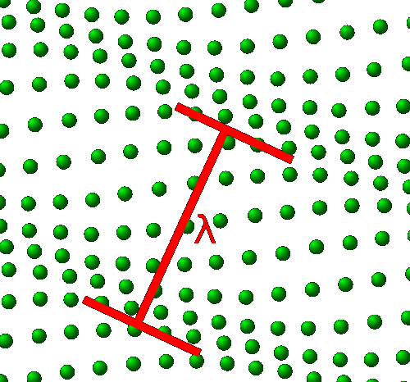
Tables should have normal weight, solid, single-line borders and be numbered consecutively from Table 1 onwards. Use Times New Roman, 9-pt font with single line spacing and 3-pt spacings before and after in every cell. Make table headings in bold font. The table structure should be clear, with simple column headings giving all units. Unaltered computer output and notation are generally unacceptable. Refrain from using scientific notation as output by computers, e.g. 1.0e+6 is not acceptable.
Material | Mass density (kg/m³) |  | Longitudinal wave velocity (km/s) | Shear wave velocity (km/s)
W | 19250 |  | 4.611 | 2.980
SiO2 | 2200 |  | 5.840 | 3.764
Air |  | 0.1 | 0.343 |  | 0.000
Table 1 Table captions should be in Times New Roman 9-pt, with the word “Table” followed by the table number in bold. Place caption below the table.
Captions for figures and tables should be in Times New Roman 9-pt font. Ensure figures and tables are within the printable area of the page. Place captions below the element. The bounding box for a caption should not be wider than the width of the associated figure or table.
Citations in the text should follow the convention of superscript numbers¹. Multiple references can be cited together by separating them with comma(s) ^{1,2}. Ranges of more than two references should be cited by separating them with a dash¹⁻³. Numbering of referenced works should be in sequence of citation appearance in the text.
Referenced works are to be listed in a dedicated section at the end of the extended abstract. This section cannot be co-located with any figures or tables. Times New Roman 9-pt font should be used for the list. The format for references should be: name of authors (initials of all names then family name, authors are separated by commas), Title of book or journal name in italic, Vol. Number in bold, (optional) issue number in (brackets), page numbers, and year in (brackets). In case of conference proceedings, underline the conference. Book publisher and place information should follow the book title as shown in Ref. 1.
Figure 1 Figure captions should be in Times New Roman 9-pt, with the word “Figure” followed by the figure number in bold. Place figure captions below the figure. Subfigures should be identified with small case letters from the Latin alphabet and referred to in the caption in bold, surrounded by (brackets), for example (a) and (b).

References
¹ J.D. Joannopoulos, R. D. Meade, and J.N. Winn, Molding the Flow of Light, Princeton University Press, USA (1995).
² I. El-Kady, R. H. Olsson III, and J. G. Fleming, Appl. Phys. Lett. 92, 233504 (2008).
³ R. H. Olsson III, I. El-Kady, and M. R. Tuck, EUROSENSORS 2008, 3–8 (2008).

